Audrey Flack

Audrey Flack is an American artist best known for her photorealistic paintings; she paved the way in the field of photorealism partly by being the first artist to use photographs as a base for her works. Her career started in the 50’s with abstract expressionism. In her abstract works she sometimes hints at forms, but in others she gives a clear identity to objects that may seem out of focus to the viewer.
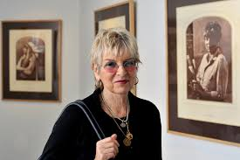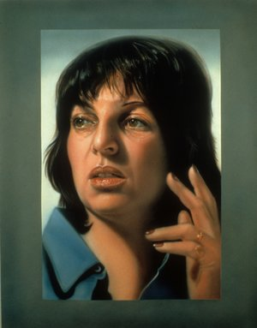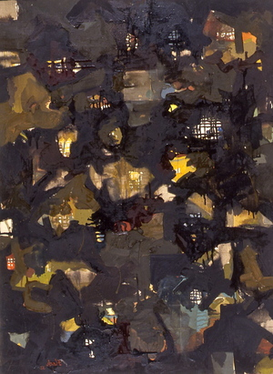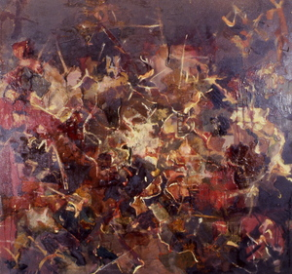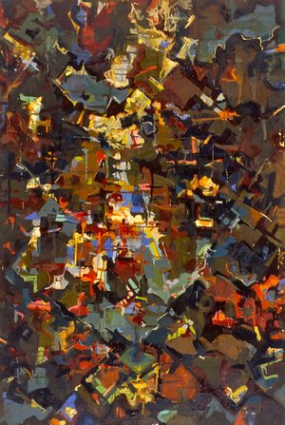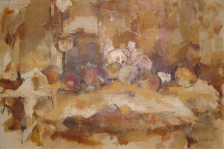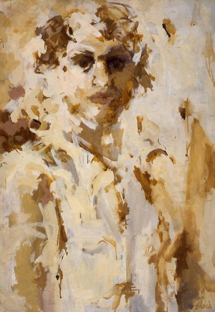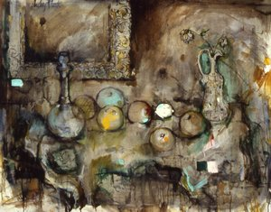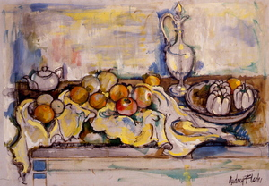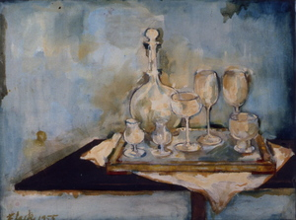

Her art embraced the style of the current culture as she transitioned into photo-realism. She did so because she wanted her works to have a clearer and more relatable message to her audience, while also keeping a focus on women and history. There she gained her international artist identity and took off into photorealism; she became the first photorealist to have their work purchased for MoMA’s permanent collection and went into the 70’s focusing on hyper-realism or super-realism. Despite all of this, she has said that she views photorealism as restricting, and that she now finds inspiration through Baroque art.

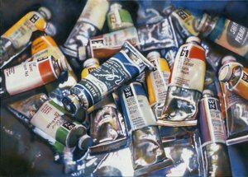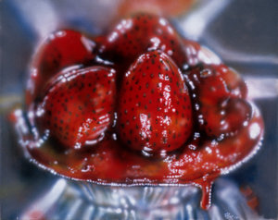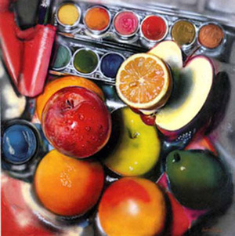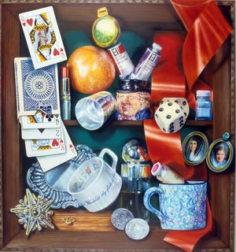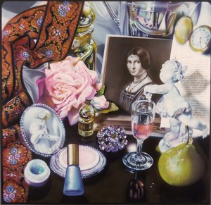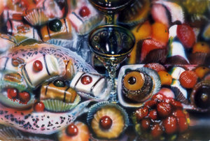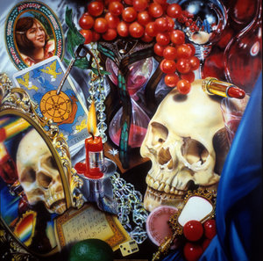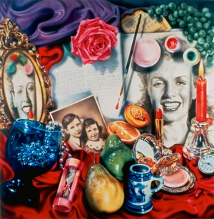

(after this, leave pause to look at works?//or slideshow through her educational stuff?)

Audrey is a heavily awarded professor with incredibly impressive credentials: a BA in fine arts from Yale, a graduates and honorary doctorate from Cooper Union, and gained her title as a Doctor of Fine Art from Clark University in 2015. She has also stemmed into a few more artistic directions: Sculpture and Music. As a musician, she performs with her Art Band to communicate their knowledge of artists from an artists perspective. She is self taught in sculpture, her lesser known medium that is a polar opposite of her paintings. Through sculpture, she tries to speak less from a historical narrative, but more fantastical. She sculpts relating to mythology and religion, mainly depictions of women, to stray from the everyday tone her photos carry. Flack is an incredibly well-rounded and educated artist, dedicated to spreading knowledge and creativity.

